Live Access
The O2 Apollo Manchester welcomes patrons with access requirements. We work alongside Attitude Is Everything to improve facilities and the quality of our service to access patrons. We are Silver-rated on Attitude Is Everything’s Charter of Best Practice.
Patrons wishing to apply for Live Access tickets will be asked to provide proof of disability at the time of their first booking. This is kept on file for future bookings.
Contact details for all access enquiries
Email: Box Office Manager on access@o2apollomanchester.co.uk Please include as much information as possible, and state whether you prefer contact via telephone or email. We aim to reply to emails within 5 working days.
(Please note: for on-sales, emails received before the on-sale time will not be considered)
Telephone: 0161 273 7785 (12.00pm – 4.00pm weekdays, extended for on-sales)
Alternative formats
Braille – available from the venue, contact 0161 273 7785 for details
Audio – available from the venue, contact 0161 273 7785 for download
Access in & around the venue
After doors have opened (usually 7.00pm, check social media or contact the venue for updates), level access is available to the side door. Please alert Front Door security staff upon arrival.
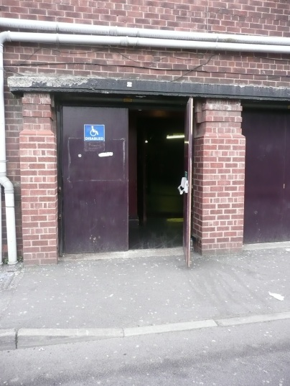
Level access throughout the Stalls area; minimum of 40 stairs to the Circle (no lift).
Parking / travel
Parking designated for disabled patrons is available in the front car park (Hyde Road side of the building), issued on a first come, first served basis. Open from one hour before doors. Additional general car parking is available on the opposite side of the building.
The 192 bus connects the venue to Manchester city centre, via Piccadilly Rail Station. There is a bus stop directly opposite the venue. Most 192 services have low level access (www.tfgm.com for timetables).
Personal Assistants tickets
Personal Assistant tickets are available upon presentation of a DLA/PIP or similar form, subject to availability. Please contact us for more information. Please be aware that access tickets can sell out very quickly; we recommend contacting us as soon as an event is announced.
All access and complimentary PA tickets should be booked together, directly with the venue on 0161 273 7785. Regrettably, we cannot amend bookings made elsewhere.
Box office
Located at the front of the building, there are two steps but there is an access buzzer straight through to box office (staffed on event nights from 5.00pm – 9.00pm approximately). Staff are also available outside.
Viewing platforms
- Standing shows: one viewing platform to the rear of the Stalls (standing area), House Right. Patrons may be accompanied by one companion (seat provided); additional companions may stand alongside the platform. Designated member of staff on duty throughout the event.
Viewing platform:
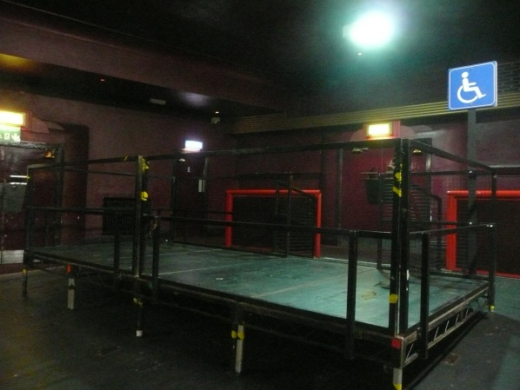
View from the platform:
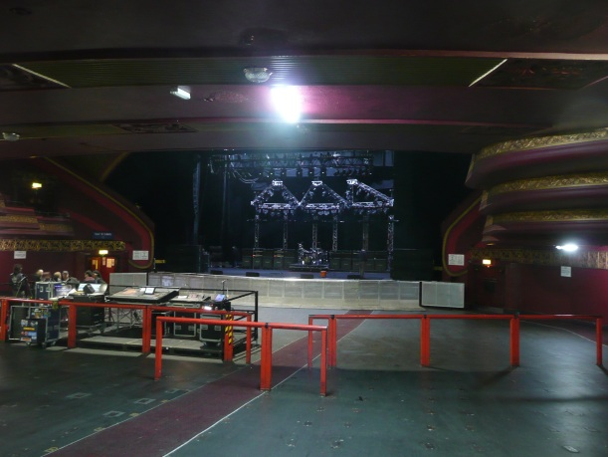
- Seated shows: access / wheelchair positions located in the front Stalls. For wheelchair users, one companion may be seated behind. Staff can assist if required.
View from the access / wheelchair area:
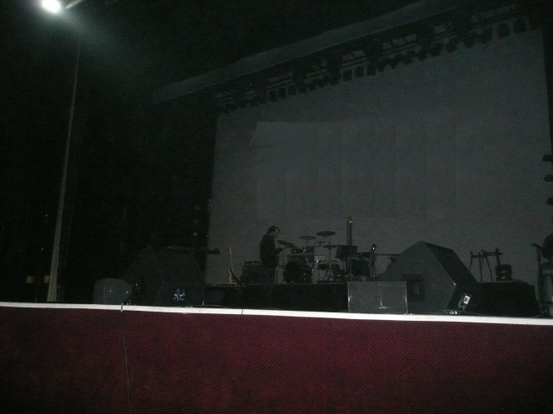
Accessible toilet
One unisex accessible toilet to House Left in the Rear Stalls. This facility is kept locked; please approach any member of O2 Apollo Manchester staff for access. Step-free access from within the venue.
Hearing Loop
There are no Hearing Loops in the auditorium at the present time. Please contact us for assistance. Loop fitted in the Box Office.
Assistance Dogs
We are happy to accommodate assistance dogs. Where possible, please advise us in advance of the show and advise which Assistance Dogs UK organisation the dog is registered with. Patrons should contact us to discuss on 0161 273 7785.
Strobe lighting
Strobe and / or bright lighting is used during most events at this venue. This is included in the Terms & Conditions of purchase, but signage is usually used when excessive use is expected. Please contact the venue if you have any specific concerns on 0161 273 7785.
Medical services
St John’s Ambulance staff are on duty at all events. They can be contacted at their First Aid Room in the front Stalls bar, or via any member of O2 Apollo Manchester staff.
We welcome customers who need to bring medicines, food, drink, equipment etc to manage a medical condition. Where possible please advise us in advance of the event on 0161 273 7785.
Smoking area
Staff can facilitate exit and re-entry for patrons who wish to smoke.

